**Experiment No: 5**

|  |
| --- |
| **Student Name and Roll Number:** Kartavya Magoo |
| **Semester /Section:** 5th semester/ FSA-1 |
| **Link to Code:** |
| **Date**: 31st August 2021 |
| **Faculty Signature:** |
| **Marks:** |

|  |
| --- |
| **Objective(s):**  Implement First Come First Serve algo |
| **Outcome:**   * The students will understand commands used in Linux. |
| **Problem Statement:**  Implement the problem |
| **Background Study:** |
| **Question Bank:** |

**Student Work Area**

**Algorithm/Flowchart/Code/Sample Outputs**

CODE :

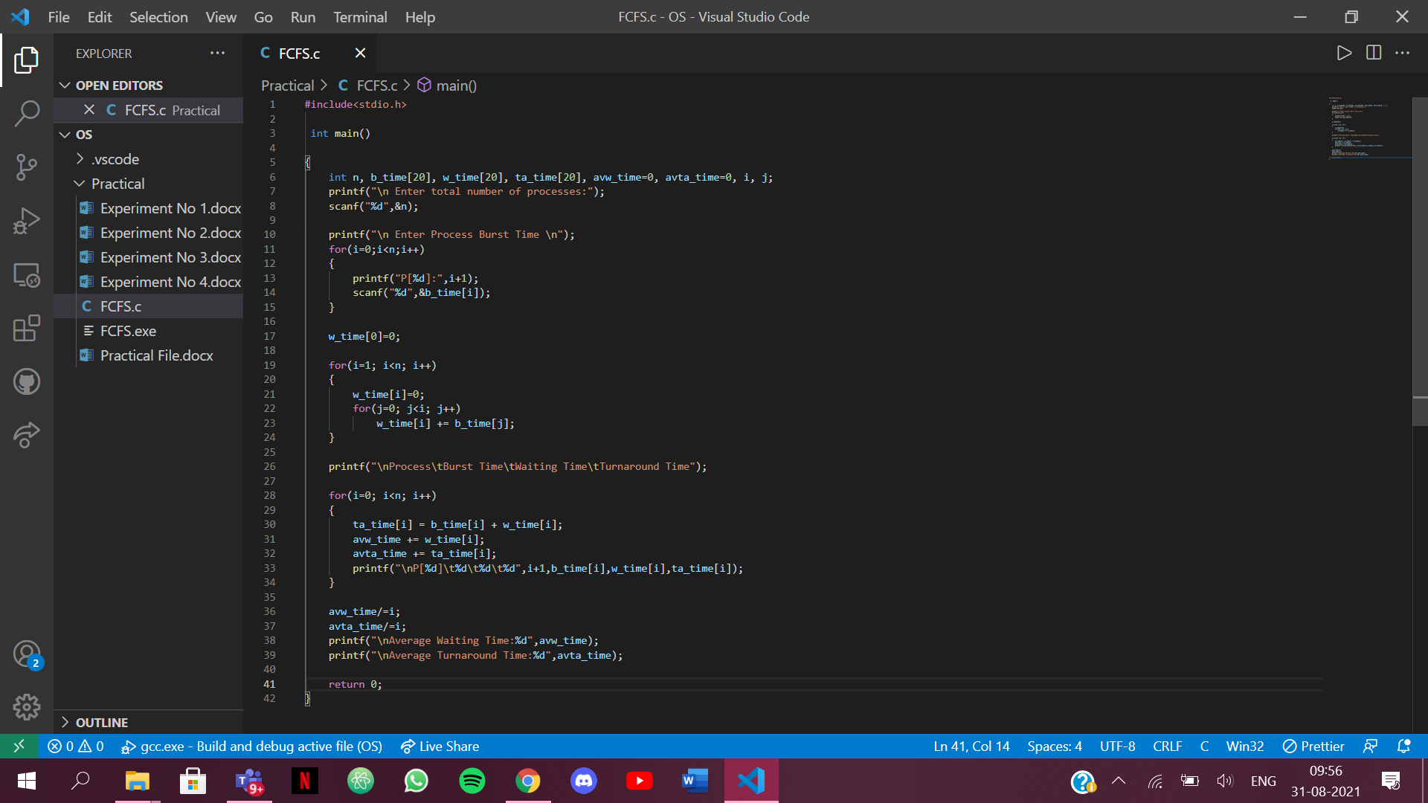

OUTPUT:

